Google Classroom Joining Instructions

Google classroom will be used to offer cadets optional training during the extended break from regular training. Cadets are encouraged to join their designated classrooms. The classrooms are as follows, 779 Training- Open to All, Level 4, 5 and 5+ and Music Training. These classrooms will contain activities that will utilize training and knowledge that has been taught within the cadet program. New activities will be added to the classroom each week. Once you have joined a classroom you will have access to activities and instructions.

Incentive program:
- Engagement in additional cadet activities remains optional and will have no adverse impact on the cadet’s success.
- A reward program will be established in the form of points and raffle ballots.
- Each activity will be worth a set number of points. These points will vary depending on type and size of the activity.
- The rewards program is administered by 779 Staff. All decisions regarding the allocation of rewards is at the sole discretion of 779 staff under the direction of (CO and TO)

- Points will be clearly identified on each activity, once cadets return to the unit, these points will be converted into ballots. 1 point = 1 ballot.
- Cadets without computer access can bring their completed activities to the unit upon the return to training.
- Each classroom will have its own set of prizes (minimum 3 draws per group)
- Level 4s and above who join both groups are only eligible for the Level 4, 5 & 5+ classroom draw, however they can earn points in both classrooms

Requirements
Cadets will require access to a computer or tablet, internet and a google account. Google accounts are free to set up and use

Cadets without or with limited internet access are asked to contact 2Lt vander Velden for accommodations

If you know of someone who does not have access to internet please contact 2Lt vander Velden

Class Codes

779 Training-Open to All: 3lxcjdo

Level 4,5 &5+: 6x65pby
Levels 4 and above may join both classrooms.

MUSIC TRAINING

Music Training/Band cadets will have access to a seperate Google Classroom. This Classroom is run by the music training staff and is separate from regular training. The music training classroom will also have a point system in place.

Once you have joined the music training classroom you will have access to resources and staff.

Music training- ccrysce
How to Join
- If you do not already have a google account (gmail account), you will have to create one
  - Make sure your google profile shows your first and last name. (you can't earn points if we don't know who you are)
- Once you have an account, login
- Click on the google apps icon

- Scroll through the icons and locate google classroom, click on it
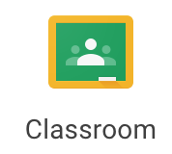

- Locate the + sign in the top right corner, click on it and select “join class”

- Enter your class Code, select join

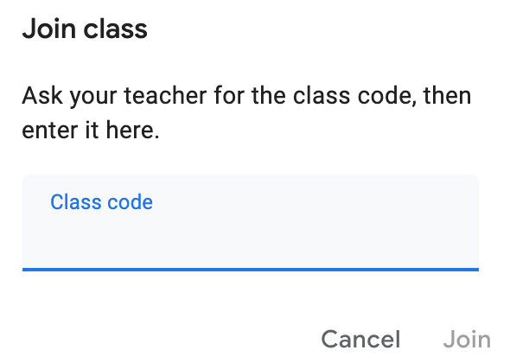

- Congratulations, you have successfully joined the class!

Once you have joined a classroom, you will have access to the activities under the “classwork” tab. Here is where you will also upload completed activities.

If you have access concerns, please direct them to 2Lt vander Velden at kvandervelden779@gmail.com

